
Analytic Approach
Crisis Help Classification
Slavova,Katerina K.S.
2025
Contents
The Problem 2
Dataset 2
Preprocessing 2
Model 4
Evaluation 5

The Problem
The goal of this project is to develop an AI Crisis Help Classification system that analyzes a disaster-related text message and predicts which humanitarian needs apply to each message. The labels include intent (request or offer of help), needs (shelter, water, food, medical help, etc.) and contextual labels such as disaster type. A single message can belong to multiple labels, which is why this task is formulated as a multi-label text classification problem.

Dataset
- Source – the data comes from the publicly available disaster response dataset originally released by Figure Eight/Appen and later hosted on GitHub (https://github.com/Bhardwaj-Saurabh/Project-Disaster-Response-pipeline.git)
- Type of data – the input data consists of real text messages related to disasters in English and in their original language.
- Target – a set of 36 binary labels describing the content of a message (intent, basic needs and context). Multiple labels can apply to one message at the same time.

Preprocessing
- Text normalization – lowercasing, removing extra spaces, handling special characters
- Tokenization – breaks the raw text into smaller units and maps each to a numerical Id from the model’s vocabulary; models cannot work directly with raw text
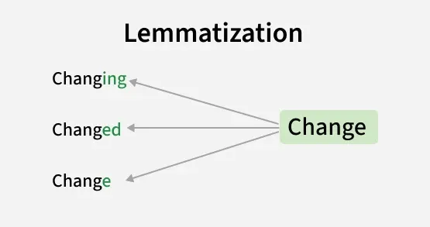
- Lemmatization – reduces words to their base or dictionary form to ensure words with similar meanings are treated the same and reduce redundancy

- Term Frequency – Inverse Document Frequency – a statistical method used to measure how important a word is to a document(text); used for keyword identification
    - Term Frequency – measures how often a word appears in a document(text)
    - Inverse Document Frequency – measures how rare a word is across the entire text

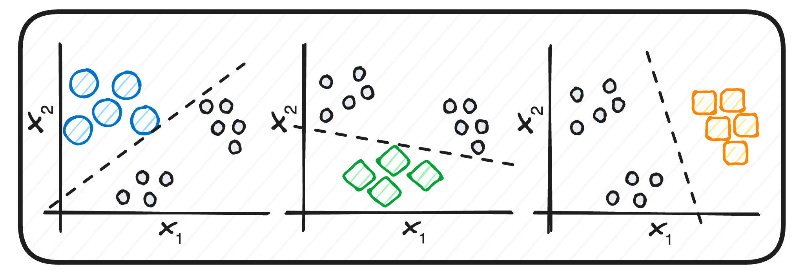
Model

For the first 4 models, I will use the “One vs Rest” strategy because of the multi-label classification – a separate classifier will be trained for each label in the dataset. At the end, all classifiers will be applied in parallel to allow the models to handle multi-label outputs.
- Multinomial Naive Bayes - a machine learning model used for text classification. It checks which words appear in a message and how often. For each label, it learns which words are common in messages and which are not. For each new message, the model uses this knowledge to estimate a probability for each label.
- Logistic Regression – each word feature is assigned a weight indicating how strongly it supports or does not support a given label. The model uses the sigmoid function to calculate the probability for each label and returns a vector of probabilities.
- Linear SVM – a machine learning model used for classification problems. Similar to the Logistic Regression, it assigns weights to each word feature. Then, it tries to find the best boundary(hyperplane) that separates the messages with a specific label from messages without this specific label. In the end, it produces a score for each label and if that score is above a certain threshold, the label is marked as present.
- Random Forest – a machine learning model that combines many decision trees. Each tree will create if-then rules to make a prediction. The forest will use the majority vote as a final prediction. With the “One vs Rest” strategy, one model will be created for each label.
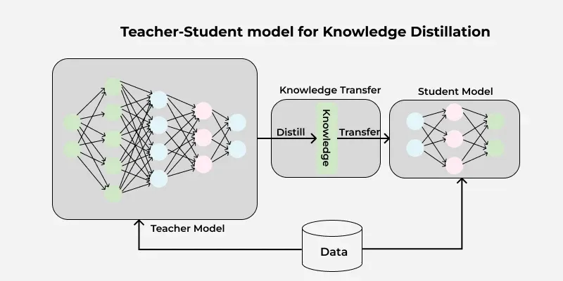
- DistilBERT – a transformer-based language model trained using the knowledge distillation technique – a smaller student model learns to replicate the behavior of a larger teacher model (BERT).
In this project, the model will read the whole message and learn the meaning of the words. The text will be first tokenized and passed to the model. On top will be added a layer with one neuron per label. Each neuron will take the input and output a score for the specific label. Finally, each score will be passed through a sigmoid function to return the predicted probability.

Evaluation
- Micro-averaged F1-score – sums the TP, FP and FN over all labels and uses these values to calculate a single F1-score; gives an overall number that shows how well the model performs across all labels
- Macro-averaged F1-score – computes F1-score for each label and takes the average of those scores; treats all labels the same and shows how the model performs on less frequent labels
- Hamming loss – the fraction of incorrectly predicted labels; gives an error rate overview
- Jaccard similarity – compares the set of predicted labels to the set of true labels for each message

